President’s Ride – Porepunkah
Friday 17, Saturday 18 & Sunday 19 March 2023

For those who cannot depart on the Friday morning, Porepunkah is 325km / 3:30 via the [M1], [M80], [M31], Snow Road [C522] and Gt. Alpine Road [B500]. The boring bit takes 2:40.
Ride instructions will not be provided by. Read this page and print it before departure, noting the freeway exits. A rider will not be directed to mark freeway exits. Someone might choose to, but don’t count on it. If separated from the ride call or text the Ride Leader or TEC. If the issue is not a breakdown proceed to the next re-group location in bold.

Friday – Depart at 9am
The last lunch booking at the Mountain View Hotel is 1:15. Café Cirino to Whitfield is 3:45 plus stops, so a 9am departure allows 30 minutes for a couple of quick stops.
Café Cirino > Melbourne Road > [M1] > [M80] > exit to Plenty Road [C727] > Whittlesea …68
Join the ride at Café 59 on Church, Church Street for a 10am departure.
Whittlesea > Yea (+60km) > Ampol, Mansfield (+78km) > Whitfield (+62km) ………+200/268
Mount View Hotel. Tel. 5729 8270.
Whitfield > King Valley > Snow Road > Great Alpine Road > POREPUNKAH …………+103/371
Mount Buffalo Holiday & Caravan Park, Mt. Buffalo Road. Tel. 5756 2380. 1km to the pub.
https://www.discoveryholidayparks.com.au/caravan-parks/victoria/victorian-alpine-mount-buffalo
Mt. Buffalo Caravan Park, Harrison Lane. Tel. 5756 2235. 2km to the pub.
https://mtbuffalocaravanpark.com.au/
Porepunkah Pub, Nicholson Street. Tel. 5756 2111. Dinner 7pm both nights.
https://porepunkahpub.com.au/

Saturday ride and lunch suggestions:
https://www.victoriashighcountry.com.au/destinations/
Mount Buffalo Chalet: Mount Buffalo Road[C535]. 55km return to Porepunkah.
Buckland Valley: Buffalo River Road [C526] via Myrtleford.
Great Alpine Road [B500] to Hotham Heights (alt. 1,840m), 63km & 1 hour +?
https://www.visitvictoria.com/see-and-do/road-trips-and-itineraries/the-great-alpine-road
Ovens & Kiewa Valley Loop: Porepunkah > Bright [B500] > Tawonga Gap Road [C536] > Mt. Beauty > Kiewa Valley [C531] > Happy Valley [C534] >Ovens > Porepunkah [B500]
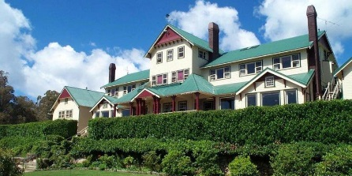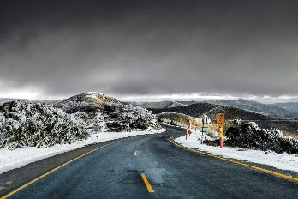
Wandi Pub, Mores’s Creek Road, Wandiligong (14km via Bright). Tel. 0418 866 633.
https://www.thewandipub.com/ Renovations still ongoing?
Gapsted Wines, Gt. Alpine Road, Gapsted. Tel. 5751 9100. 31km from Porepunkah.
https://www.gapstedwines.com.au/pages/gapsted-wines-cellar-door
…/Sunday departure

Sunday – Depart at 08:45
- Porepunkah > Gt. Alpine Road > Snow Road [C522] > Whitfield [C521] …………..(1:15) 103
Whitfield > Mansfield (+62km) > Yea (+78km) …………………………………….……(1:45) +140/243
Meet other WMCC members at the Country Club Hotel for lunch at 12:30.

- Quicker route to Yea saving 35 minutes:
Porepunkah > Gt. Alpine Road [B500] > Snow Road > BP Hume [M31] (+75km) > Midland Highway [B300] exit (+32km) > Swanpool > Merton > Yea [B300] (+117km) …………. (2:25) 224
Yea > Whittlesea > Plenty Road [C727] > Ring Road [M80] > M80/M1 interchange ….+116/359

Tail End Charlie: 0493 394 472.

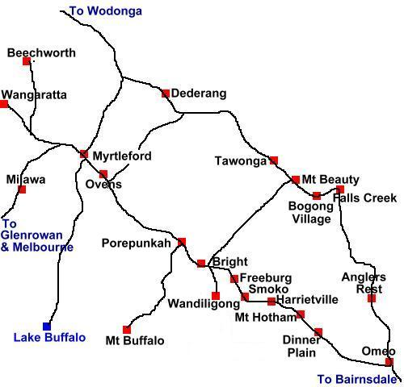

May I suggest print and carry?

